**PARENT SURVEY**

Dear Respondent,

The department of _Engineering__ require feedback from our stakeholders i.e Alumni, Employers, Parents, Students and Staff, to gauge whether the B Tech (_CSE) Programme offered by our department is sufficient in preparing the students to be competent engineer for professional life after their graduation.

The objective of the survey is:

1. To collect the suggestions for reviewing the vision and mission of the department
2. To gather information on the importance of the Program Educational Objectives (PEO), Program Outcomes (POs) and Program Specific Outcomes (PSOs) statement
3. To gauge graduates accomplishments after graduation (PEO) and alsot o measure their attributes after completing the Programme (POs & PSOs)

We are grateful if you could spare some time to complete this survey



Name of the Parent: Rajinder Parshad

Year of Admission:

1. Indicate how well do you agree with the mission and vision of department (refer annexure)
   1. Strongly disagree
   2. Disagree
   3. Can’t say
   4. Agree
   5. Strongly agree
2. Indicate how well do you agree with each Program Educational Objectives PEOs (refer annexure) as a predicted accomplishment for the degree

|  |  |  |  |
| --- | --- | --- | --- |
| **Program Educational Objectives (PEOs)** | **Degree of relevance** | | |
| **Slight (1)** | **Moderate (2)** | **Substantial (3)** |
| PEO1 |  |  | Strongly agree |
| PEO2 |  |  | Strongly agree |
| PEO3 |  |  | Strongly agree |
| PEO4 |  |  | Strongly agree |

1. Do you suggest any changes in PEOs? (Specify)



NO

1. Indicate how well do you agree with each Program Outcomes POs as predicted accomplishment for this program

|  |  |  |  |
| --- | --- | --- | --- |
| **Program Outcomes (POs)** | **Degree of relevance** | | |
| **Slight (1)** | **Moderate (2)** | **Substantial (3)** |
| PO1: Engineering Knowledge: Apply the knowledge of mathematics, science, engineering fundamentals,  and an engineering specialization to the solution of complex engineering problems |  |  | Strongly agree |
| PO2: Problem Analysis: Identify, formulate, review research literature, and analyze complex engineering problems reaching substantiated conclusions using first principles of mathematics, natural sciences, and  engineering sciences |  |  | Strongly agree |
| PO3: Design/Development Of Solutions: Design solutions for complex engineering problems and design system components or processes that meet the specified needs with appropriate consideration for the public health and safety, and the cultural, societal, and environmental considerations |  |  | Strongly agree |
| PO4: Conduct Investigations of Complex Problems: Use research-based knowledge and research methods including design of experiments, analysis and interpretation of data, and synthesis of the information to provide valid conclusions |  |  | Strongly agree |
| PO5: Modern Tool Usage: Create, select, and apply appropriate techniques, resources, and modern engineering and IT tools including prediction and modeling to complex engineering activities with an understanding of the limitations |  |  | Strongly agree |
| PO6: The Engineer and Society: Apply reasoning informed by the contextual knowledge to assess societal, health, safety, legal and cultural issues and the consequent responsibilities relevant to the professional engineering practice. |  |  | Strongly agree |
| PO7: Environment and Sustain ability: Understand the impact of the professional engineering solutions in societal and environmental contexts, and demonstrate the knowledge of, and need for sustainable development. |  |  | Strongly agree |
| PO8: Ethics: Apply ethical principles and commit to professional ethics and responsibilities and norms of the engineering practice |  |  | Strongly agree |
| PO9: Individual and Team Work: Function effectively as an individual, and as a member or leader in diverse teams, and in multi disciplinary settings. |  |  | Strongly agree |
| PO10: Communication: Communicate effectively on complex engineering activities with the engineering community and with society at large, such as, being able to comprehend and write effective reports and design documentation, make effective presentations, and give and receive clear instructions |  |  | Strongly agree |
| PO11: Project Management and Finance: Demonstrate knowledge and understanding of the engineering and management principles and apply these to one's own work, as a member and leader in a team, to manage projects and in multi disciplinary environments |  |  | Strongly agree |
| PO12: Life-long Learning: Recognize the need for, and have the preparation and ability to engage in  independent and life-long learning in the broadest context of technological change |  |  | Strongly agree |

1. Indicate how well do you agree with each Program Specific Outcomes (PSOs) predicted accomplishment for this programme

|  |  |  |  |
| --- | --- | --- | --- |
| **Program Specific Outcomes (PSOs)** | **Degree of relevance** | | |
| **Slight (1)** | **Moderate (2)** | **Substantial (3)** |
| PSO1 |  |  | Strongly agree |
| PSO2 |  |  | Strongly agree |

1. Do you suggest any changes in POs and PSOs?

NO

Place:Kurali Signature:

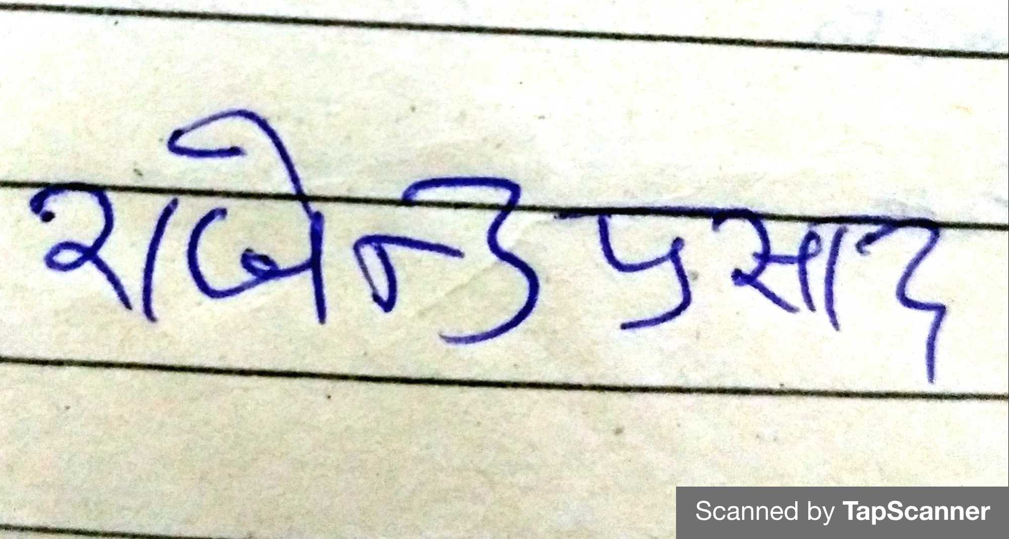

Date: 22-06-2021 Name and Designation: Rajinder Parshad

The Department of _Engineering______ would like to thank you for your willingness in spending your valuble time to complete this questionnaire. Your time and effort is much appreciated.

**Please refer to annexure for the details about vision and mission of the department**

Head of the department

**ANNEXURE**

**Vision of the Department**

To be recognized as a leading Computer Science and Engineering department through effective teaching practices and excellence in research and innovation for creating competent professionals with ethics, values and entrepreneurial attitude to deliver service to society and to meet the current industry standards at the global level.

**Mission of the Department**

**M1:** To provide practical knowledge using state-of-the-art technological support for the experiential learning of our students.

**M2:** To provide industry recommended curriculum and transparent assessment for quality learning experiences.

**M3:** To create global linkages for interdisciplinary collaborative learning and research.

**M4:** To nurture advanced learning platform for research and innovation for students’ profound future growth.

**M5:** To inculcate leadership qualities and strong ethical values through value based education.

**Department Program Educational Objectives (PEOs)**

**PEO 1:** To produce computer science graduate engineers with an ability to comprehend, understand and analyze real life problems for providing sustainable solutions teams in the light of disruptive technologies.

**PEO 2:** To inculcate life-long learning skills in graduates preparing them for work in changing environments and multidisciplinary teams in order to enhance their capability being globally employable.

**PEO 3:** To instill leadership qualities in graduates with a sense of confidence, professionalism and ethical attitude to produce professional leaders for serving the society.

**PEO 4:** To make the graduates adaptable to changing career opportunities who have the potential to excel in industry/ public sector/ higher studies or entrepreneurship exhibiting global competitiveness.

**Department Program Specific Objectives (PSOs)**

**PSO1:** To acquire proficiency in developing and implementing efficient solutions using emerging technologies, platforms and free and open-source software (FOSS).

**PSO2:** To gain critical understanding of hardware and software tools catering to the contemporary needs of IT industry.